Two-Day National symposium on
‘CURRENT RESERACH TRENDS IN LIFESCIENCE’
Organised by
Department of Biosciences
In association with
Institutions’ Innovation Council (IIC)
28.02.2023 & 29.02.2023
REPORT
The Department of Biosciences and the Institution’s Innovation Council (IIC) collaborated to organize a Two-day National Symposium in celebration of National Science Day, focusing on 'Current Research Trends In Life Sciences' on the 28th and 29th of February 2024 at MES M.K Mackar Pillay College for Advanced Studies, Edathala, Aluva. The event commenced with a solemn prayer, establishing a reverent ambiance for the inauguration. Ms. Febina Ferose, Head of the Department of Biosciences, extended a warm welcome to all attendees, fostering a hospitable atmosphere.Dr. Murugan R, Principal, delivered an insightful introductory speech, delineating the visions and objectives of the National Symposium.Adv. M. Ahamedkunju, Chairman of the College Managing Committee, shared his reflections on the Symposium's significance and the role of Research in its promotion while chairing the session. Dr. Ajims P. Muhammed, Principal of MES College Marampally, officially inaugurated the two-day national symposium, symbolizing the commencement of its journey. Adv. M.M. Salim, Secretary and Correspondent of the College Managing Committee, honoured the chief guest. M.A Abdullah, Treasurer of the College Managing Committee; P.K.A Jabbar, Vice Chairman of the College Managing Committee; C.M. Asharaf, Joint Secretary of the College Managing Committee; Mr. V.M. Lagheesh, Vice Principal and Mr. R. Rahul Thampi, IIC President, offered felicitations during the ceremony. Expressing gratitude, Ms. Jesna Muhammed C.M ,Programme Coordinator, extended heartfelt thanks to all participants and supporters for their valuable contributions. Head of Departments and other faculty members from various departments were present. The event concluded with a rendition of the national anthem, fostering a profound sense of unity and patriotism.
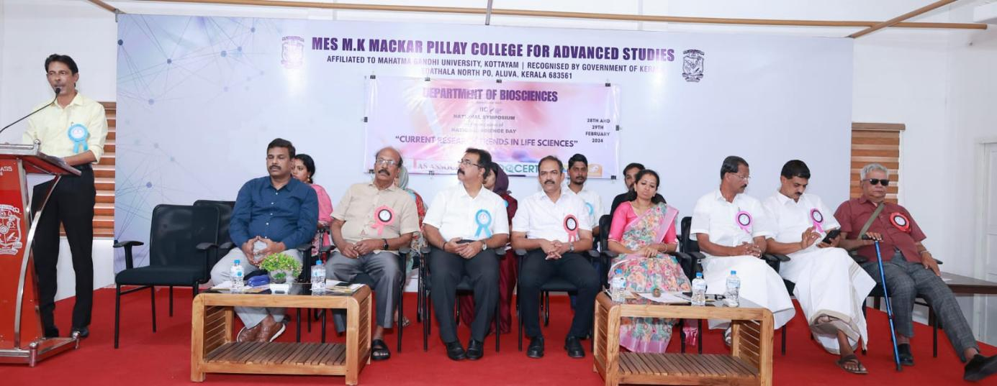
Inauguration of Two-day National symposium on ‘Current Research Trends In Life Sciences ‘by Dr.Ajims P Muhammed.
SESSION 1
28.02.2023, 11.30 am-12.30pm
Handled by Dr.T Rajaswaminathan

The session-1 seminar delved into the intriguing topic of "Emerging Fish Viral Diseases and Their Control." Attendees were enlightened about the intricate details surrounding newly emerging viral diseases impacting fish populations. This included a comprehensive exploration of their symptoms, pathology, and transmission dynamics.

Participants were guided through an exploration of different viral pathogens, including those from families such as Rhabdoviridae, Iridoviridae, and Flaviviridae, among others. They gained insights into the symptoms, pathology, and transmission dynamics associated with these diseases, enabling a deeper understanding of their impact on fish populations.Moreover, the seminar delved into the spread and distribution of viral diseases among fish populations, elucidating factors influencing disease transmission and outbreak patterns. Attendees also learned about the development and optimization of diagnostic techniques for early detection and surveillance of viral diseases in fish populations.The session further emphasized the importance of implementing effective control measures to prevent, manage, and mitigate the impact of viral diseases on fish populations. Strategies discussed included vaccination, biosecurity protocols, and various treatment options.

Throughout the seminar, engaging discussions and interactive question-and-answer sessions enriched the learning experience, offering valuable insights and perspectives. The session concluded with a compelling call to embrace emerging technologies and engage in continued research efforts to advance our understanding and management of fish viral diseases. This underscored the collective commitment to safeguarding the health and sustainability of aquatic ecosystems.

.
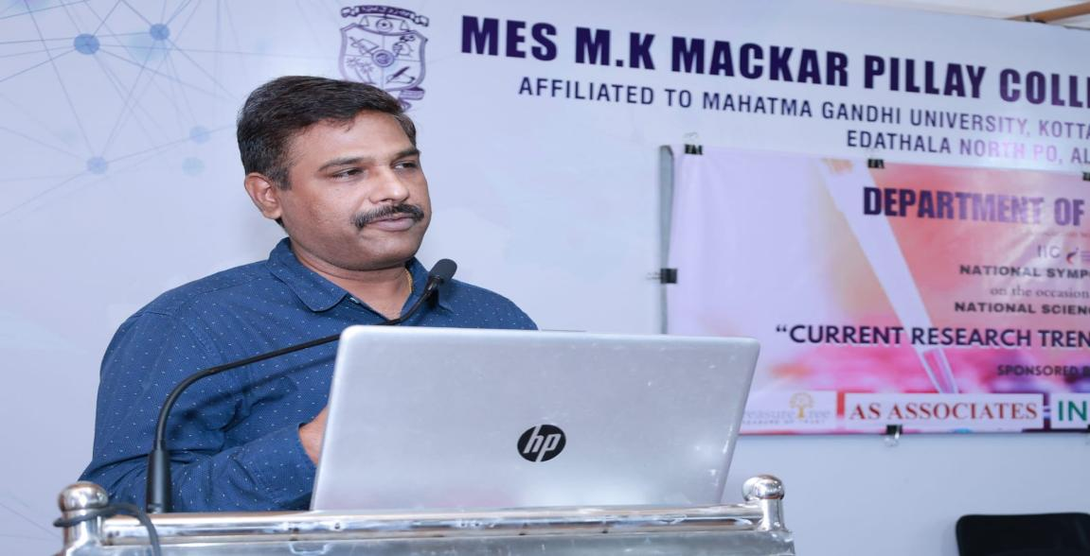
Session 1 by Dr.T Rajaswaminathan

SESSION 2
28.12.2023, 2.00pm-3.00pm
Handled by Dr.Arathi Dharmaratnam

During the comprehensive session on "Fish Cell Lines & Their Applications," participants delved into the fundamental aspects of fish cell lines, gaining insights into their origin, distinctive characteristics, and diverse types. Through engaging discussions, attendees explored the pivotal role of fish cell lines in evaluating the toxicity levels of chemicals, pollutants, and environmental contaminants, thereby contributing significantly to environmental and public health assessment.
Simultaneously, the workshop illuminated the expansive realm of applications facilitated by fish cell lines. Attendees delved into the myriad of possibilities, from enhancing our understanding of aquatic pathogen detection to advancing biotechnological endeavours such as vaccine production and gene expression studies. Moreover, the discourse extended towards addressing the pressing challenges and limitations inherent in fish cell line research.
Particular emphasis was placed on the imperative need for enhancing cell line authenticity, streamlining protocols, and envisioning innovative applications to propel the field forward. By fostering dialogue around these critical topics, participants gained valuable insights into the evolving landscape of fish cell line research, paving the way for future breakthroughs and advancements in this dynamic field.
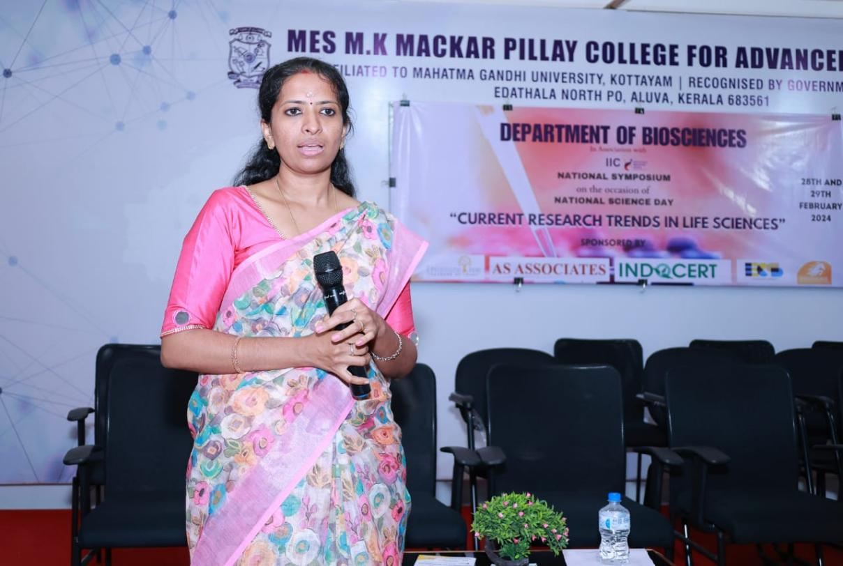
Session 2 by Dr.Arathy Dharmarathnam

SESSION 3
28.12.2023, 3.15pm-4.30pm
Paper Presentation
Handled by Dr.Arathi Dharmaratnam, Ms.Febina Ferose

The Paper Presentation Competition served as a stirring tribute to the indomitable spirit of academic inquiry and intellectual pursuit. It provided a vibrant platform for participants to unveil their scholarly achievements, engage in enriching dialogue, and ignite the flames of inspiration for future generations of researchers and scholars.
As the final curtains gracefully descended on the competition, participants departed infused with a renewed sense of purpose, armed with a treasury of fresh insights and forged connections that epitomized the essence of shared intellectual endeavours. The event served as a poignant reminder of the transformative potency inherent within the realm of knowledge, igniting a fervent quest for excellence that resonated throughout the academic community.With nearly 11 students gracing the stage with their intellectual prowess, the competition bore witness to a cornucopia of talent and ingenuity. The most outstanding papers were bestowed with well-deserved accolades, complemented by prize money and certificates, underscoring their remarkable contributions to the academic discourse.
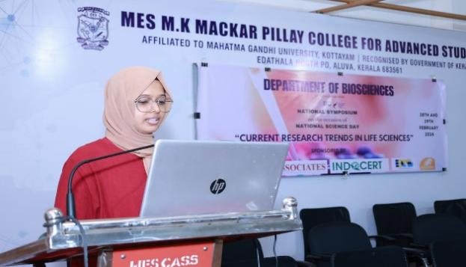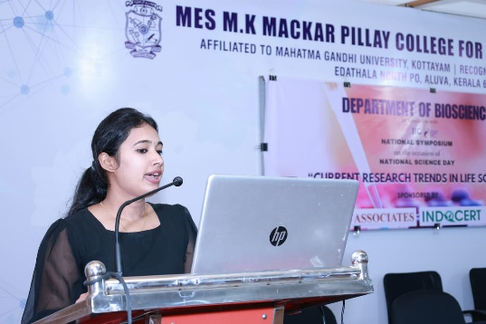
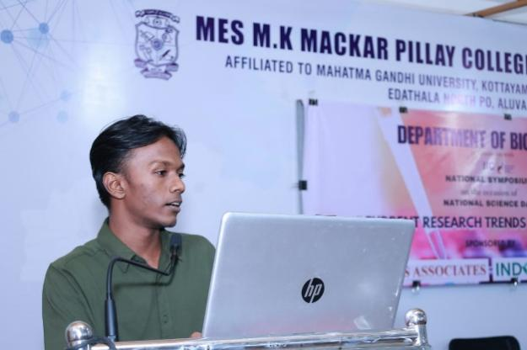

Session 3: Students presenting their paper

SESSION 4
29.12.2023, 10.00pm- 11.00pm
Handled by Dr.Anjana J C
The seminar provided a captivating journey into the intricate interplay among bio- entrepreneurship, research, and innovation, within the dynamic landscape of biotechnology and life sciences. Bio-entrepreneurship, a field rapidly gaining momentum, entails the application of entrepreneurial principles to propel scientific breakthroughs from the confines of the laboratory to the vast expanse of the marketplace. We delved into the fundamental tenets of bio-entrepreneurship, unravelling its profound significance in bridging the chasm between scientific ingenuity and commercial fruition. Central to this exploration was an in-depth examination of the indispensable role of research as the bedrock of bio-entrepreneurship. We underscored the critical importance of both foundational and translational research in catalysing innovation and driving transformative change. A highlight of the seminar was its spotlight on the emergent trends and prospective horizons in bio-entrepreneurship. We delved into the transformative potential of digital technologies, the meteoric rise of biotech start-ups, and the democratization of access to biotechnology tools and resources. These trends not only redefine the contours of bio-entrepreneurship but also herald a new era of innovation and discovery within the life sciences.
In essence, the seminar served as a beacon of enlightenment, illuminating the path forward for aspiring bio entrepreneurs and seasoned innovators alike. By fostering dialogue, igniting inspiration, and cultivating collaboration, we aim to propel the bio entrepreneurship ecosystem towards unprecedented heights of achievement and impact.
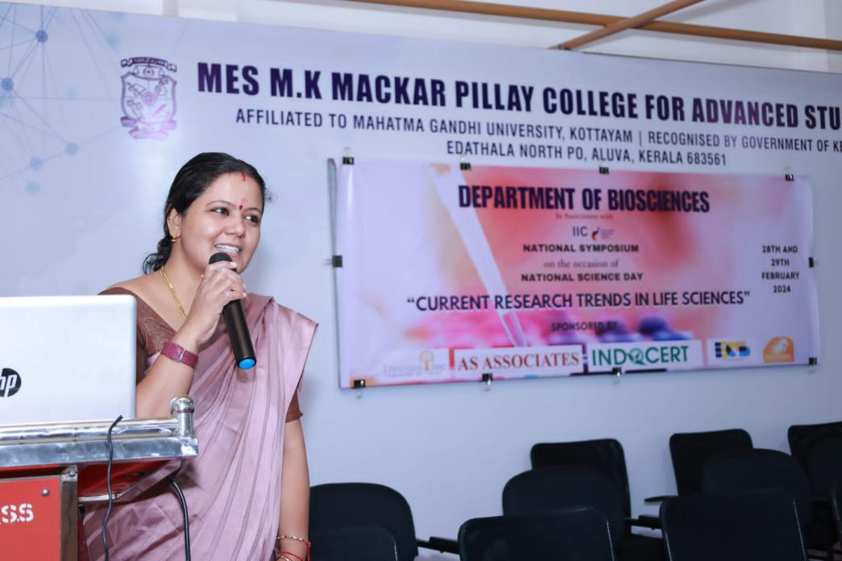
Session 4 by Dr.Anjana J C

VALEDICTORY SESSION
29.12.2023, 11.15pm

In this transformative seminar, which traversed the latest trends in life sciences, participants embarked on a profound exploration of this dynamic field. Throughout the seminar, attendees delved deeply into the cutting-edge advancements and emerging paradigms within life sciences, igniting discussions and fostering new insights.
In the culminating valedictory session, the esteemed Principal, Dr. R. Murugan, and Dr. Anjana JC presided over the ceremony with grace and distinction. It was a moment of honour as they graciously presented certificates of recognition to the participants, resource persons, and coordinators who contributed tirelessly to the success and vibrancy of the seminar.
This symbolic gesture not only celebrated the collective achievements and endeavours of all involved but also underscored the spirit of collaboration, dedication, and scholarly pursuit that defines the essence of such transformative gatherings.

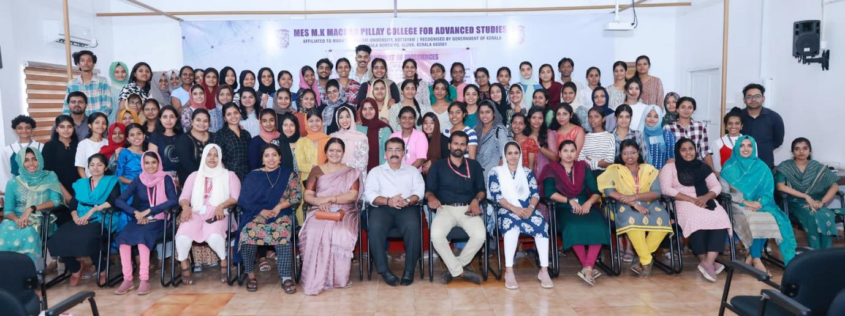
Valedictory function Dr.Anjana J C with the students

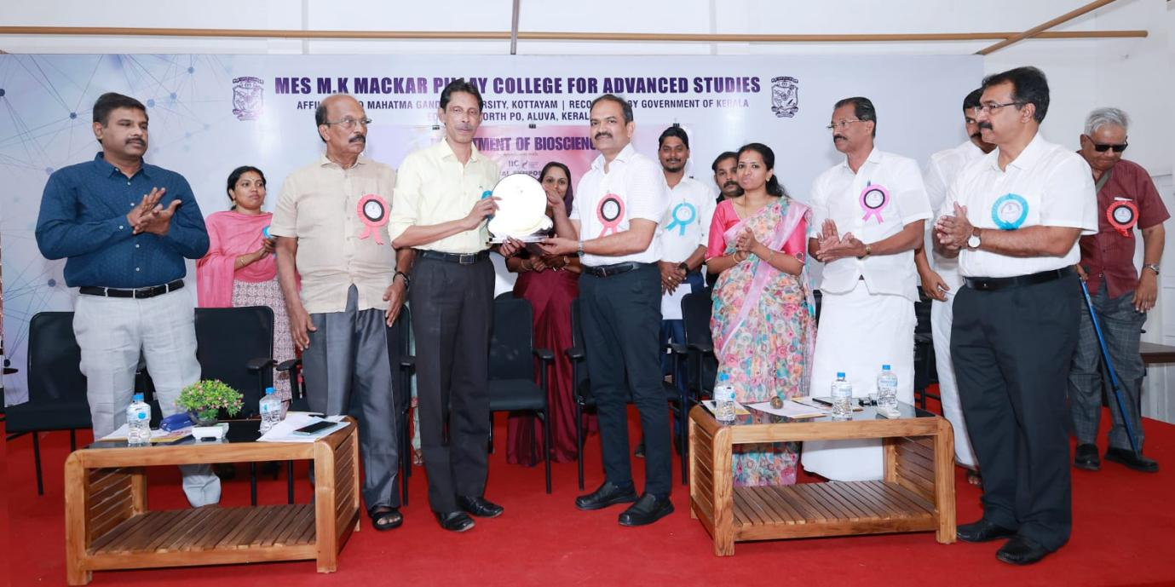Secretary and Correspondent of the College Managing Committee, honouring the chief guest 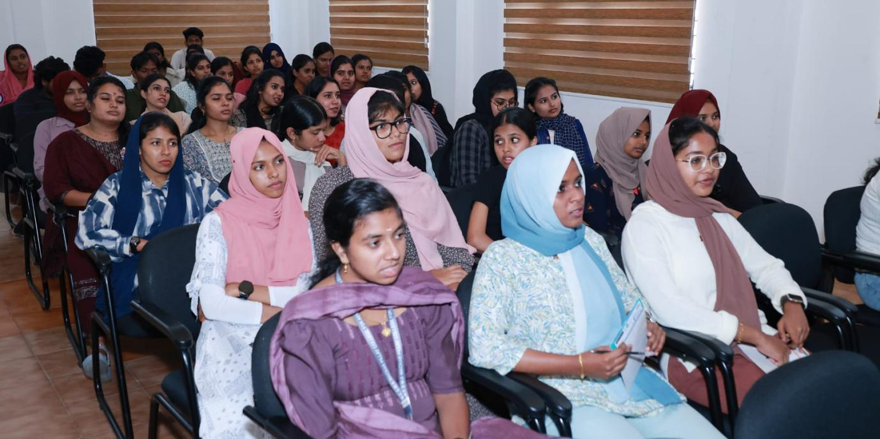
Students participating the seminars
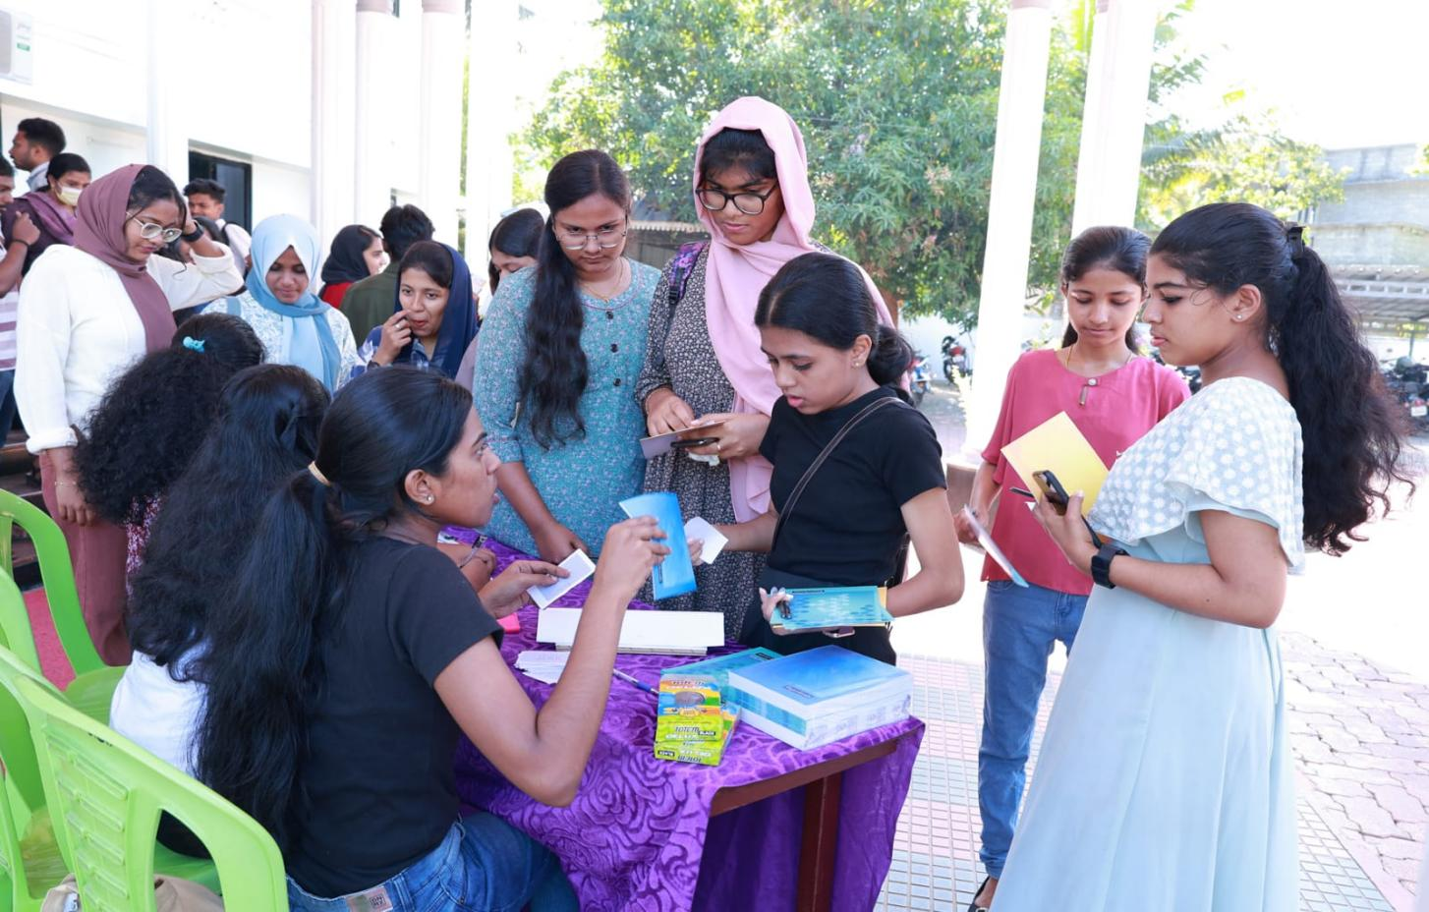 At the registration desk, students are registering for the seminar.
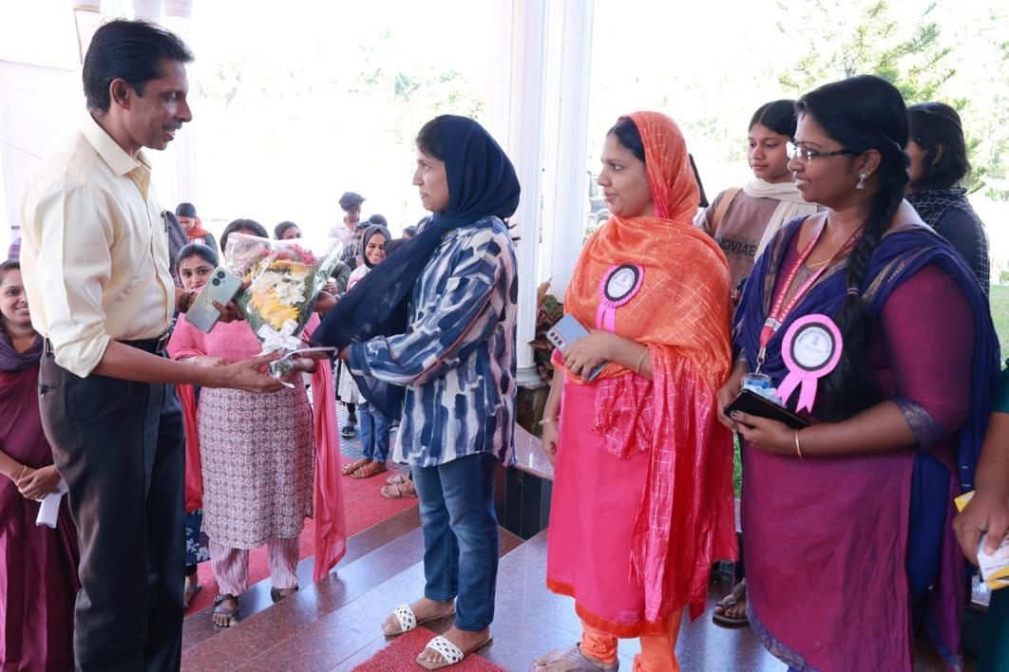
Receiving the guest.

“CURRENT RESEARCH TRENDS IN LIFE SCIENCES”
NATIONAL SYMPOSIUM
Department of Bio sciences
Financial Statement
SL NO | PARTICULARS | INCOME | EXPENSE | NOTES
1 | Indocert | 5000 |  | Sponsorship
2 | AS associates | 5000 |  | Sponsorship
3 | Treasure tree | 3000 |  | Sponsorship
4 | Adex | 5000 |  | Sponsorship
5 | Whitehorse International Academy | 2500 |  | Sponsorship
6 | Registration fee | 16850
7 | Brochure |  | 104
8 | Flex |  | 1240
9 | Food & Refreshments |  | 17275
10 | Stationary |  | 2827
11 | Fuel Expense |  | 450
12 | Prize Money |  | 3500
13 | Resource Person |  | 4000
14 | Certificates |  | 2282
15 | Photography |  | 1500
16 | Bouquet |  | 250
17 | Memento |  | 960
 | Total | 37350 | 34388
 | Total Income | 37350
 | Total expense | 34388
 | Profit | 2962

