**HANDS ON TRAINING ON MUSHROOM CULTIVATION**

**Organized By**

**Department of Bioscience**

**In association with**

**Institution’s Innovation Council and ED Club**

**Programme Coordinator: Ms.Rajeena C.A DATE: 30/01/2024**

# REPORT

Department of Biosciences organized a Hands-on Training on Mushroom Cultivation in association with Institution’s Innovation Council of MESCAS and ED Club. The workshop was conducted on 19/01/2024 at 10.00am in the college seminar hall. Ms.Rajeena C.A was the programme coordinator.

The event commenced with a solemn prayer, setting a respectful tone for the Inauguration. A warm welcome was extended to all attendees, creating a hospitable atmosphere by Ms.Febina Ferose, HOD of Biosciences. Dr. Murugan R, Principal, Inaugurated the Ceremony. Mr. Lagheesh V. M, Vice Principal, Rahul Tampi R, Institution’s Innovation Council MESCAS President, Ms. Divya Antony, Staff Secretary, Ms. Bushara V.B, ED Club Coordinator given felicitations for the ceremony. Ms. Rajeena C.A, Programme Coordinator, thanked all participants and supporters for this training workshop.

The resource person of this programme was Anitha Jaleel, Proprietor of M/s. Jerry Mushroom who has secured Karshika Vikjana Vyapana Award in 2021. The session included both theory and practical with a vast description on essential steps required for the cultivation of mushroom.She gave an idea regarding the spawn preparation, basic requirements, the cultivation of mushroom, etc. After that demonstration was carried out by preparing the mushroom bed along with students.

About 101 students from Biosciences department, ED Club and third year students from BBA department were registered and participated in this training programme and other faculty members from Biosciences and various departments were present. E- Certi icates were provided to all participating students. The event concluded with a rendition of the national anthem, fostering a sense of unity and patriotism . The workshop ended at 1.00PM.

**RAJEENA C. A**

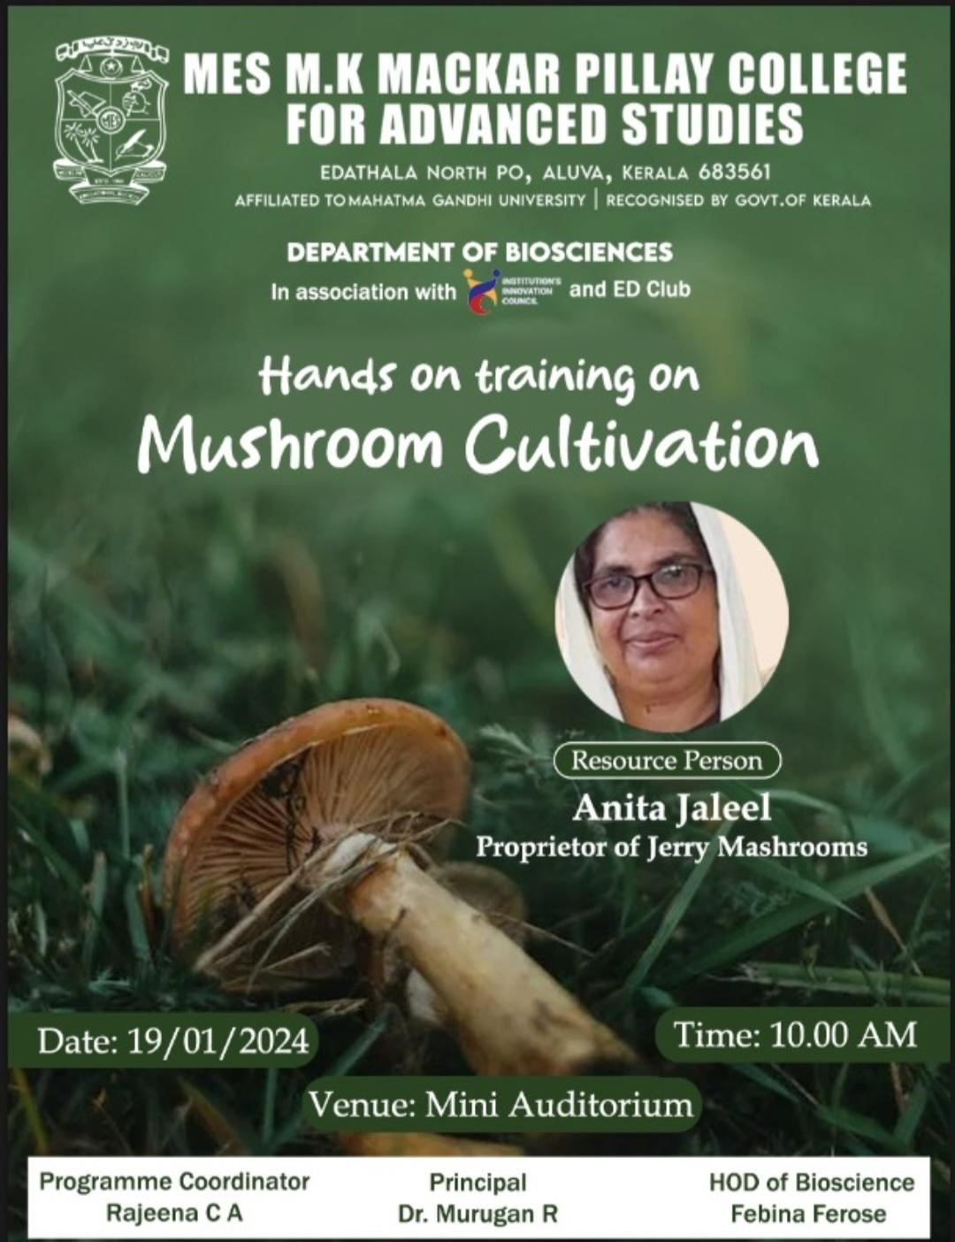

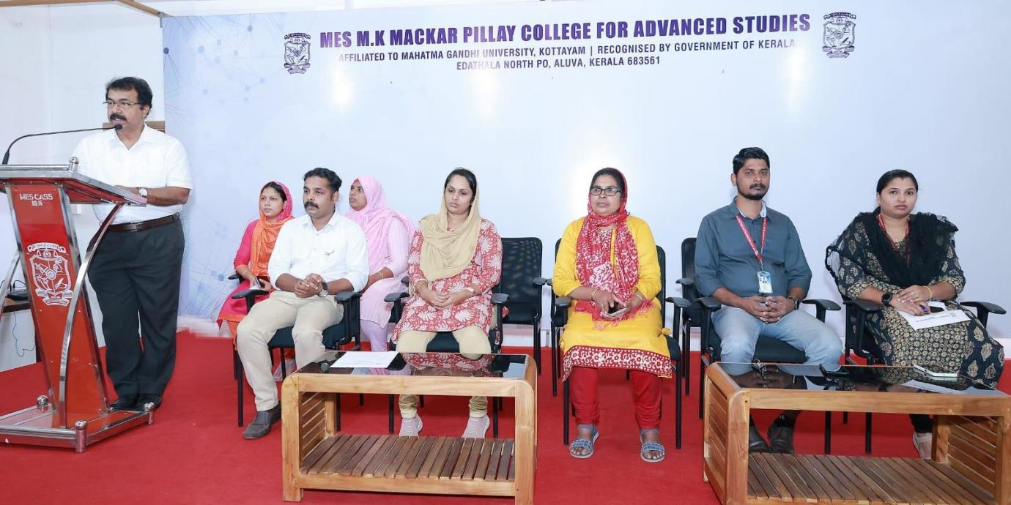

Hands on Training on Mushroom Cultivation Inaugurated by Dr. Murugan. R, Principal of MESCAS

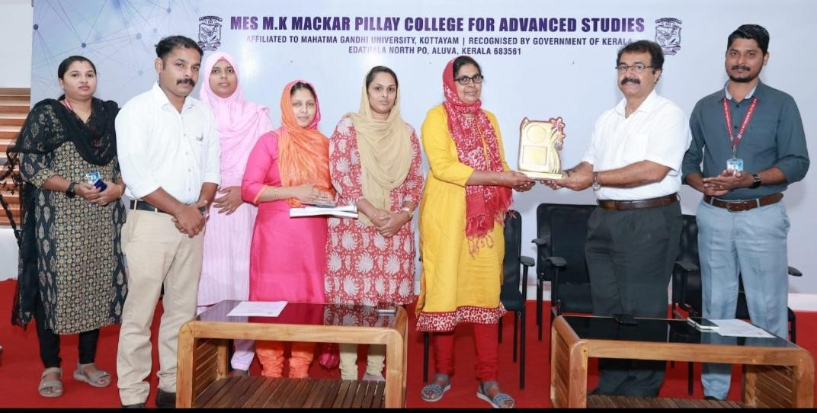

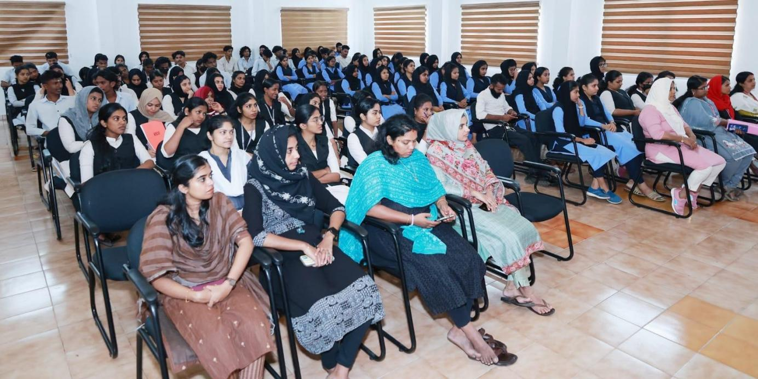

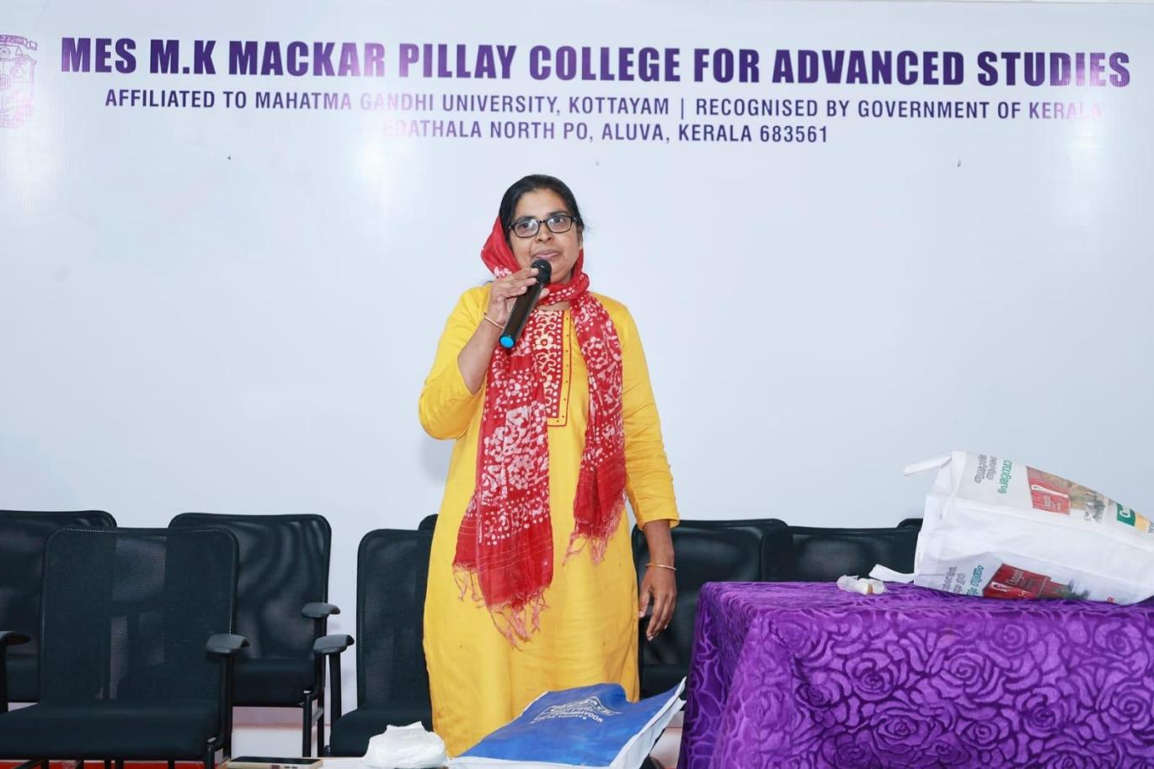

Talk session by Resource Person, Anita Jaleel (Proprietor of Jerry Mushroom)

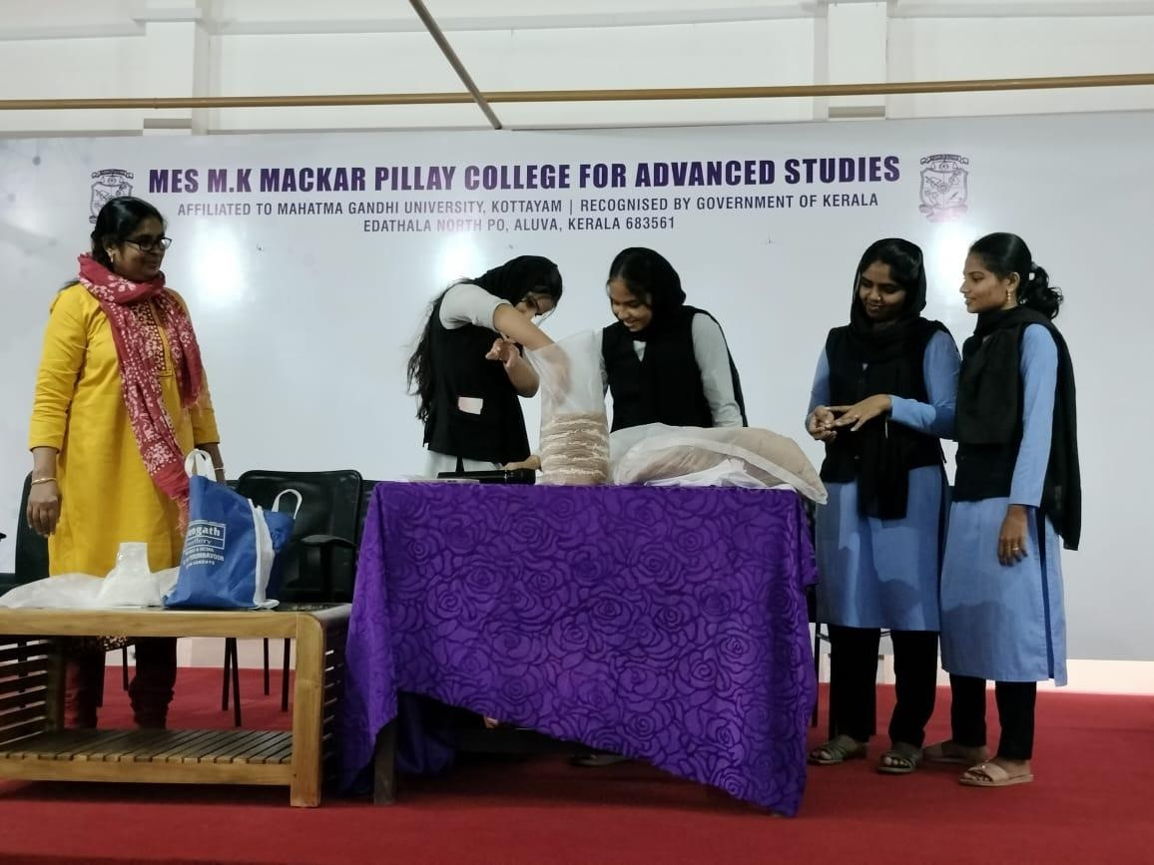

Demonstration class along with students

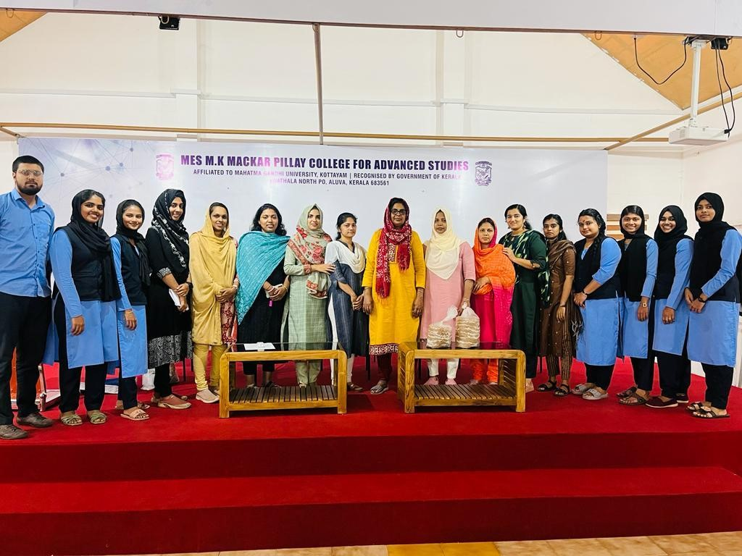

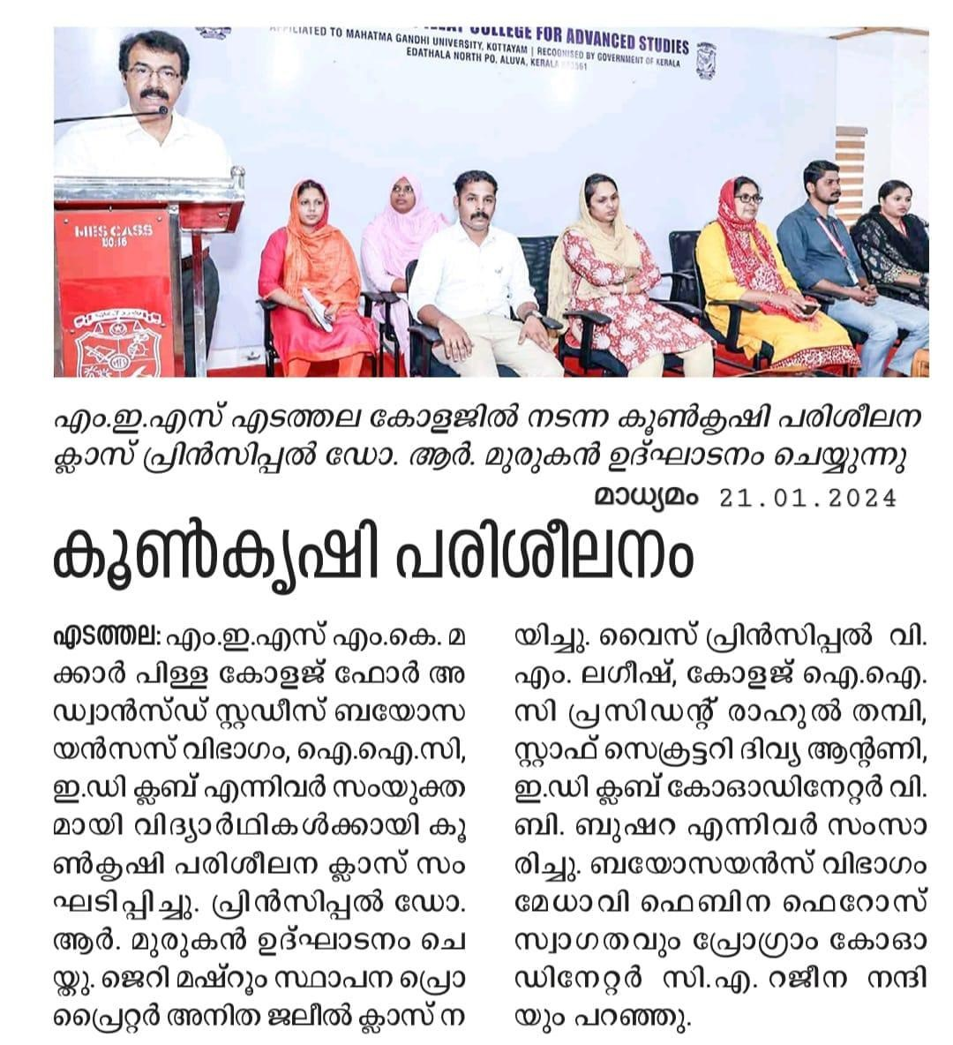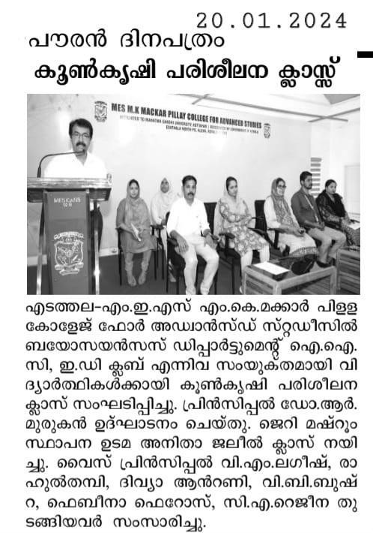

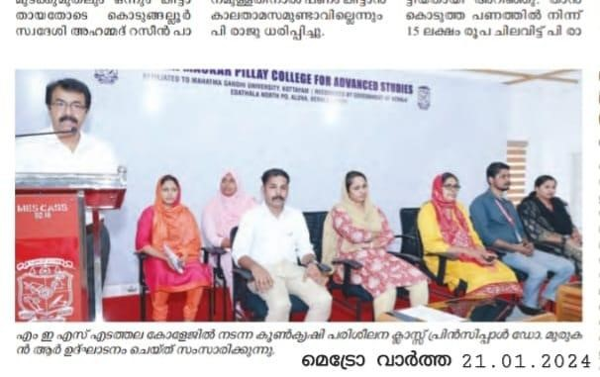

**Programme Coordinator**

**RAJEENA C.A**

## HANDS ON TRAINING ON

## *MUSHROOM CULTIVATION*

**PROGRAMME SCHEDULE**

**19TH JANUARY 2024**

**TIME : 10.00 AM**

**VENUE : SEMINAR HALL**

***Session I : Inauguration Ceremony (Time : 10.00 AM)***

**PRAYER**

**WELCOME SPEECH : Ms. FEBINA FEROSE (HOD OF BIOSCIENCES)**

**INUAGURAL ADDRESS : Dr. MURUGAN R ( PRINCIPAL)**

**FELICITATION : Mr.LAGEESH V. M (Vice Principal of MESCAS)**

**: Mr. RAHUL THAMBI R (MESCAS IIC President)**

**: DIVYA ANTONY (Staff Secretary of MESCAS)**

**: Ms. BUSHARA V.B (ED Club Coordinator)**

**VOTES OF THANKS : Ms. RAJEENA C. A (Program Coordinator)**

***Session II: Talk Session (10.30 AM – 12.30 PM)***

**RESOURCE PERSON : ANITHA JALEEL (Proprietor of Jerry Mushroom)**

**NATIONAL ANTHEM**